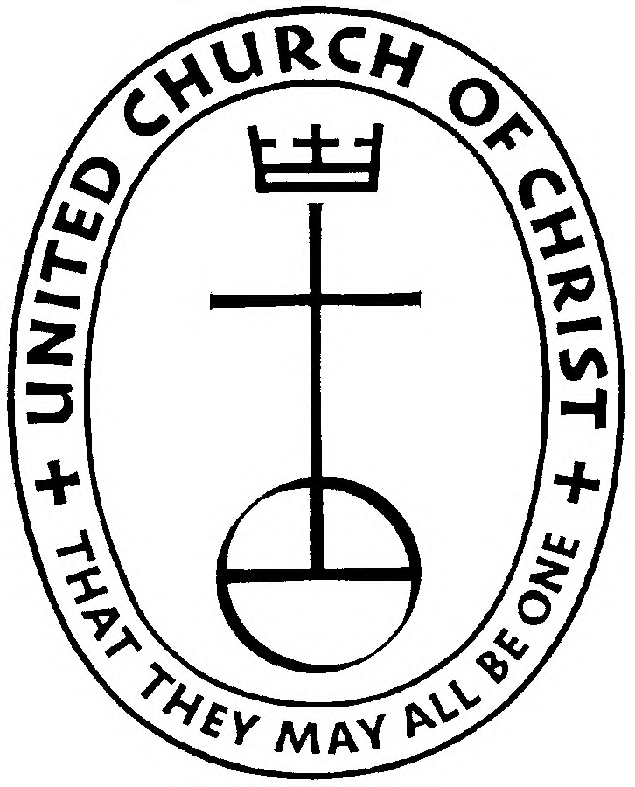
THE VINCENT VIEW

September 2020

Discerning God’s Will

“Knowing God’s will for our lives is knowing what God created us for.” Rose Mary Dougherty SSND
How can we be in harmony with God and God’s will? It begins with a desire and openness to being in harmony with what God is doing and what God desires us to be a part of.
Sometimes we have the understanding that God’s will for us and our will are typically in conflict and being a good Christian is laying down our will to take up God’s will. This might be the case, but I would like to suggest another possible understanding.
God’s will for us is based on who we are and what we were gifted to be. The conflict we experience between our will and God’s will happens because our will does not come from our core desires but from the “shoulds” that have been placed upon us by others and the successes and failures of our life experiences. Part of the discernment process is to clear out the “shoulds” in our life so that we have the freedom to discover who God created us to be, discover our “core will”, and in so doing realize true freedom.
When we discover and accept our “core will” (what we were created to be) it can feel like coming home or it may feel like a great work teasing out the “core will” from the image we have of ourselves and our experience that seems opposite of who God has created & gifted us to be.
Generally speaking, a person can recognize that she or he is ready to enter into a period of discernment to discover their “core will” when questions like: “Is this all there is?” Or “There must be something more then what my life is now.”
Rose Mary writes: “At some point in the spiritual journey we are awakened to this love affair (with God ejk) and the subsequent choice to claim the primacy of love in our lives. For some this may show itself as an insatiable passion for truth or for justice, for others it may be a deep reverence for beauty and still for others it may appear as the drawing of the heart to compassionate service. Others may sense beneath the pain, the joy, the compliancy of their lives, there is a reality that can no longer be ignored.” (pg.15 of Group Spiritual Direction by Rose Mary Dougherty SSND; Paulest Press © 1995
I encourage you to read the first few chapters of Exodus at least to the point where Moses encounters God at the “Burning Bush” and receives his assignment and tells God that God has made a mistake and that God should get someone else more qualified.
Moses as a young adult (Ex.2:11-15a) went to see the labor of his people. During his “inspection” he saw a Hebrew being beaten by an Egyptian taskmaster. Moses decides to take justice into his own hands and kills the offending taskmaster. On another occasion Moses again seeks justice when he tries to stop two Hebrews from fighting each other.

“A Family in Christ”

East Vincent UCC
282 Hill Church Rd.
Spring City, PA 19475

Phone: 610-935-0224

Church Email:
EastVincentUCC@
aol.com

Website:
www.evucc.com

Rev. Erick Kern
484-686-7325

Outdoor Worship
at 8:30am in the pavilion.

Moses was conflicted in that he identified with his people and wanted to give them justice and leadership but did not know how. His first two attempts were failures. Murder is not justice. The Hebrew people did not respect Moses as their leader because of being adopted as an Egyptian prince and being socially and culturally far removed from the daily Hebrew experience.
I believe that it is at this moment that Moses is beginning to sense that he was created to be more than he is. That there is a deeper meaning to his being taken from the river, adopted by Pharaoh’s daughter, nursed and raised by his own mother in infancy, and when weaned brought to Moses’ adoptive mother to be raised and educated as a prince of Egypt. At this conflicted moment in his life Moses is beginning to suspect that there is more to his life than the normal routine of Egyptian court life and work.
In his confusion and not wanting to be executed by Pharaoh, Moses flees Egypt and ends up at a well in Midian on the other side of the Sinai Peninsula. Moses begins his “wilderness period” where he will have the time he needs to figure out or discern what the purpose of his life is.
Resting at this well Moses once again has his sense of justice and fairness challenged when 7 shepherdesses are chased away from the well by the bullying of other shepherds.
Moses has come a long way from being a prince of Egypt living in high society, receiving the best that the civilized world has to offer becoming a shepherd in a wilderness place far from the comforts he was accustomed to.
Question: What do you suppose was happening between the time he became a shepherd and the divine encounter at the burning bush?
Possible Answer: It is my opinion that the time alone tending sheep was spent quieting his soul and preparing his soul to hear God’s voice. There is little distraction while watching sheep so thoughts can run unhindered in many directions. I believe that this was Moses’ time of discernment, his time of discovering what God gifted Moses to be and what Moses’ great mission was to be.
In Acts we are told that Moses spent 40 years (Acts 7:30: the number 40 typically symbolized trials, probation or testing) between his arrival in Midian and his divine experience at the burning bush.
It is important to realize that a bush burning in the desert is not unusual, it is not common, but it is not unusual. There is a tree whose sap is very flammable. A drop of water magnifying the rays of the sun can set it off or a drop of sap itself in the rays of the sun can set it off. The unusual part was that the fire did not consume the bush.
Thoughts on Discernment
1. One of the goals of meditation and discernment is to be awakened to the movements of God.
2. The fact that Moses was “spiritually and mentally awake” to the oddity of the burning bush shows that his time tending sheep had not lulled him into spiritual blindness but spiritual wakefulness. Moses was alert to divine possibilities. Because Moses saw the hand of God in the ordinary of daily living and was thankful, Moses was awake to greater possibilities.
3. The way that scripture reads it seems the burning bush is almost a test (Exodus 3:4ff). God observes that Moses turns to investigate the burning bush and so calls out to Moses. If Moses had not turned aside would God have found another person to lead Israel out of Egypt? Would God have known that Moses was not yet ready to lead and so give him more time to get his spirit in tune with God’s spirit?
Not Qualified: Notice that in the exchange that follows, when God tells Moses all that he is to accomplish, Moses pulls back. He believes that God has gotten the wrong person. Even though Moses had a sense that he was created for greater things, he was a failure in his own eyes having fallen from being a prince of Egypt to being a shepherd (whom we learned from the story of Joseph in Genesis) an abomination to Egyptians. So Moses has moved from one end of the social scale to the opposite end, from the panicle of society to the bottom of society. Moses may have spent time indulging in a lot of negative language about himself that would have to be addressed if Moses was ever to become the person God gifted Moses to be.
While Moses is awed by the voice and the burning bush, he also has enough sense about him to test this spirit to make sure that it is truly God or truly a messenger from God.
1. What is your name Moses asks?
2. What proof can I give that you are truly the God of Abraham, Isaac, and Jacob?

Moses has fallen so far that he suffers from self-doubt and states that he is not qualified to lead God’s people. He is only qualified to lead sheep. Moses even claims that he cannot speak well. Either he was making up an excuse or he actually did have some kind of speech problem.
God created Moses to be a great leader and I believe that Moses journey from Hebrew to Prince of Egypt to shepherd was necessary to prepare Moses to become this great leader. By human standards Moses could be considered a failure. But by Divine standards Moses was in the perfect place to be a great leader. No longer was Moses the arrogant know-it-all prince of Egypt. He was a shepherd who knew his limitations. Limitations when harnessed to God would make for the Perfect leader.

WHAT HAS GOD GIFTED YOU FOR? WHAT IS YOUR “SOMETHING GREATER?”
Another difficulty in discerning God’s will for our life and accepting that will is our image of God. What we believe God to be is the way that we will experience God. If we believe that God is harsh and an unbending tyrant then that will be our experience of God. If we believe God to be good and merciful an ever present help, then that is how we will experience God.
When I say, experience God, it maybe clearer to say that who we be believe God to be will be the God we see acting in the events and circumstances of our life.
FOR EXAMPLE: If we believe God to be a harsh, unbending tyrant then when things go wrong in our life and evil parks itself on our doorstep, God will be blamed. If God is good and merciful, a present help in trouble then when things go wrong in our life and evil parks itself on our doorstep, God will be our guide, our shield, and our champion to guide us through the trouble and bring new life out of the ashes of the old life.
Sometimes the problem with discerning God’s will for our lives comes from the limits we have placed on God and the assumptions we have about God – like who God is, God’s personality, God’s “true” self, in spite of what we were taught and confess during times of worship. Who we believe God to be and what we confess about God in conversation maybe two different things. For example, we may confess that God is a loving and merciful God but when trouble comes, when evil comes, we blame God for it. In this case what we actually believe is that God is evil, unjust, or a tyrant to name a few possibilities.
The goal of our time in “the wilderness” (the wilderness being that spiritual dry time when God seems to have rejected us or taken a vacation from helping and protecting us. The wilderness experience will be different for each person.) is to learn to be consistent in what we believe about God and to make sure that what we believe about God matches what we know about God from scriptures and especially from Jesus’ teachings. Then disciplining ourselves to consistently claim this truth about God in every event we experience so that we are not saying one thing, believing something else, then responding to life events with a confused understanding of God and God’s work in our life.
Discerning God’s will for our life is taking time to discover what God has gifted us to be. This involves delivering ourselves from the “demonic possession of the shoulds” in our life, learning God’s true identity from the teachings of Jesus, consistently applying this truth about God to every part of our life experience, and paying particular attention to what causes us to get excited, energized, or creates a “pull” on our heart or soul to the point that we wish something could be done about it. Regardless of whether we like Moses feel qualified or not is to be ignored. In Discernment we are looking for what God has gifted us for making the assumption that our life experiences both positive and negative have yet to reveal this divine giftedness.
Once we discover what gets us excited, energized, or creates a “pull” on our heart or soul to the point we wish something could be done about it, is when we begin looking for and discovering the dormant gifts that God has given us to meet this call to ministry and mission.

May you be truly be blessed.
Rev. Kern

+++++++++++++++++++++++++++++++++++

The September hoagie sale has been cancelled. The Consistory and hoagie committee will be making a decision on a month by month basis so stay tuned!!

+++++++++++++++++++++++++++++++++++

SEPT Birthdays

7 Elizabeth Cooper
8 Shane Clark
9 Bunny Cuthbert
13 Sue Romano
14 Sandy Zentz
14 Jack Shronk
22 Jeffrey Yeager
22 Kirt Kronmuller
23 Scott Kohansby
24 Stacy Gardner
24 Brandon Sturges
30 Amy Kocher

Anniversaries
6 Charles & Bunny Cuthbert
14 Nicholas & Stacy Gardner
15 Billy & Ashley Hoffman
22 Bill and Debbie Hoffman
25 John & Kelli Yeager
27 Shane and Leann Clark
29 David & Jannet Shronk

+++++++++++++++++++++++++++++++++++

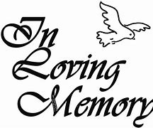
Deanna “Dee” Heffentrager, 82, widow of the late Donald Heffentrager, passed away on Monday, July 27th in Parkhouse. She is survived by her three children, LeAnn Clark (Shane), Don Heffentrager (Tracy), and Lorraine Oczypok (David), six grandchildren, and two great grandchildren. A private graveside service was held in the EV Cemetery on Saturday, August 1, 2020.

A note from LeAnn:

Dear East Vincent Church family,
Thank you for your thoughtfulness in sending the beautiful lavender colored flowers - my mother’s favorite color.
I also want to send a word of thanks to the special members who helped me with the funeral arrangements.
Our family appreciates your generosity and kindness.
Sincerely,
LeAnn Clark & family

Mission Statement: “Our mission is to praise God and serve Christ through hearing and doing the Word of God. As caring and supporting Christian disciples, we offer opportunities for spiritual growth, service, fellowship and friendship, and development of our uniqueness both as individuals and a community of faith. We reach out in love to welcome the stranger, give hope to the hopeless, and share the peace of Christ with our neighbor."

+++++++++++++++++++++++++++++++++++

EAST VINCENT CONSISTORY
Bill Hoffman, Co-Pres, 610-469-2725
Peter Dabback, Co-Pres, 610-495-7086
John B. Yeager, 610-937-0376
Tiffany Black, Secretary, 484-716-4606
Dale Lynn, 610-948-6637
Linda Theurkauf, 610-659-3000

Next meeting: Sunday, Sept 20th after worship

8:30 AM
SUNDAY WORSHIP CONTINUES OUTSIDE IN THE PAVILION
Wear a Mask / Bring a Chair!



Blood Drive in Royersford:
Be part of a lifesaving journey. Donate Blood! First UCC, Royersford, will be holding a blood drive on Tuesday, September 29th and Wednesday, September 30th from 2:00-7:00pm. Please call 1-800- RED CROSS (1-800-733-2767) or visit redcrossblood.org to schedule an appointment.



